Special Enrollment Partner Social Media Content

 | Post Content (copy and paste into your social media accounts) | Asset
Partner Post 1 | Open enrollment may be over, but if you experience a Qualifying Life Event, you can still enroll in health insurance throughout the year on @VAInsuranceMarketplace.  Learn more about which life events qualify for a Special Enrollment Period: https://www.marketplace.virginia.gov/special-enrollment | Download asset file from the Special Enrollment Partner Content folder to include in your post.  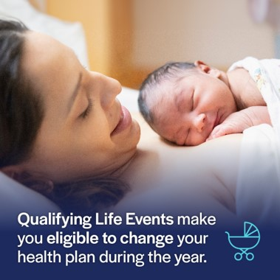  Image File Name: SEP Partner Social Post 1.jpg
Partner Post 2 | Life changes may require changes to your health plan.  Shop for a budget-friendly plan to fit your new chapter on @VAInsuranceMarketplace: https://www.marketplace.virginia.gov/special-enrollment | Download asset file from the Special Enrollment Partner Content folder to include in your post.  Video File Name: SEP Partner Social Post 2.mp4
Partner Post 3 | If you lost health insurance, you can check whether you’re eligible for savings and enroll in a budget-friendly plan on @VAInsuranceMarketplace.  Shop for health plans now: https://www.marketplace.virginia.gov/special-enrollment | Download asset file from the Special Enrollment Partner Content folder to include in your post.  Video File Name: SEP Partner Social Post 3.mp4
Partner Post 4 | Life happens. Make sure you’re covered with comprehensive health insurance for each step of the way.  Shop for health plans during a Special Enrollment Period on @VAInsuranceMarketplace: https://www.marketplace.virginia.gov/special-enrollment | Download asset file from the Special Enrollment Partner Content folder to include in your post.  Video File Name: SEP Partner Social Post 4.mp4
Partner Post 5 | A new chapter in your life could mean new health insurance needs.  Make sure your health is covered. Shop for health plans on @VAInsuranceMarketplace: https://www.marketplace.virginia.gov/special-enrollment | Download asset file from the Special Enrollment Partner Content folder to include in your post.  Video File Name: SEP Partner Social Post 5.mp4

