Open Enrollment Partner Social Media Content

 | Post Content (copy and paste into your social media accounts) | Asset
Partner Post 1 | It’s that time of year again! Shop for and enroll in a health plan on Virginia’s Insurance Marketplace today.  Get covered on @VAInsuranceMarketplace: Marketplace.Virginia.gov/new-customers | Download asset file from the Open Enrollment Partner Content folder to include in your post.  Video File Name: VIM Partner Social Post 1.mp4
Partner Post 2 | No matter which health plan you choose on Virginia’s Insurance Marketplace, your coverage will include the 10 Essential Health Benefits, like doctor visits and prescriptions.  Enroll in a plan on @VAInsuranceMarketplace now: Marketplace.Virginia.gov/new-customers | Download asset file from the Open Enrollment Partner Content folder to include in your post.  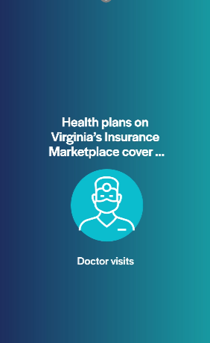  Video File Name: VIM Partner Social Post 2.mp4
Partner Post 3 | With cold and flu season around the corner, having the right coverage can prepare you for doctor visits, prescriptions, or anything else you need to feel your best.  Get coverage on @VAInsuranceMarketplace today: Marketplace.Virginia.gov/new-customers | Download asset file from the Open Enrollment Partner Content folder to include in your post.  Video File Name: VIM Partner Social Post 3.mp4
Partner Post 4 | If you’re looking for ways to save, you can find affordable health plans on Virginia’s Insurance Marketplace, and check whether you’re eligible for financial savings.  Save more on @VAInsuranceMarketplace today: Marketplace.Virginia.gov/financial-savings | Download asset file from the Open Enrollment Partner Content folder to include in your post.  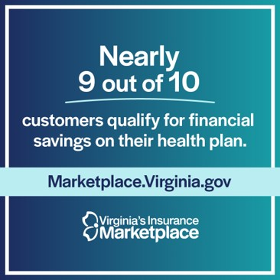  File Name: VIM Partner Social Post 4.jpg
Partner Post 5 | If you recently lost your Medicaid coverage, find an affordable plan with comprehensive coverage on Virginia's Insurance Marketplace.  Find free, in-person local assistance and get help enrolling in a plan on @VAInsuranceMarketplace: Marketplace.Virginia.gov/losing-medicaid-coverage | Download asset file from the Open Enrollment Partner Content folder to include in your post.  Video File Name: VIM Partner Social Post 5.mp4
Partner Post 6 | On Virginia’s Insurance Marketplace, you can shop for, compare, and enroll in a variety of plans.  Enroll in the right plan for you on @VAInsuranceMarketplace: Marketplace.Virginia.gov/new-customers | Download asset file from the Open Enrollment Partner Content folder to include in your post.  File Name: VIM Partner Social Post 6.jpg

