Open Enrollment Partner Social Media Content

 | Post Content (copy and paste into your social media accounts) | Asset
Partner Post 1 | Looking for a health plan that covers your routine health needs and protects you from unexpected medical expenses? ​  Find health insurance and enroll today on @VAInsurance Marketplace: Marketplace.Virginia.gov | Download asset file from the Open Enrollment Partner Content folder to include in your post.    Image File Link: OEP Partner Social Post 1.jpg
Partner Post 2 | No matter where you are in Virginia, @VAInsuranceMarketplace has you covered. Enroll in health insurance that you can count on: Marketplace.Virginia.gov | Download asset file from the Open Enrollment Partner Content folder to include in your post.    Video File Link: OEP Partner Social Post 2.mp4
Partner Post 3 | From doctor's visits to prescriptions, get comprehensive coverage that fits your family's health needs on @VAInsuranceMarketplace.​  ​  Enroll in a health plan by January 30: Marketplace.Virginia.gov | Download asset file from the Open Enrollment Partner Content folder to include in your post.  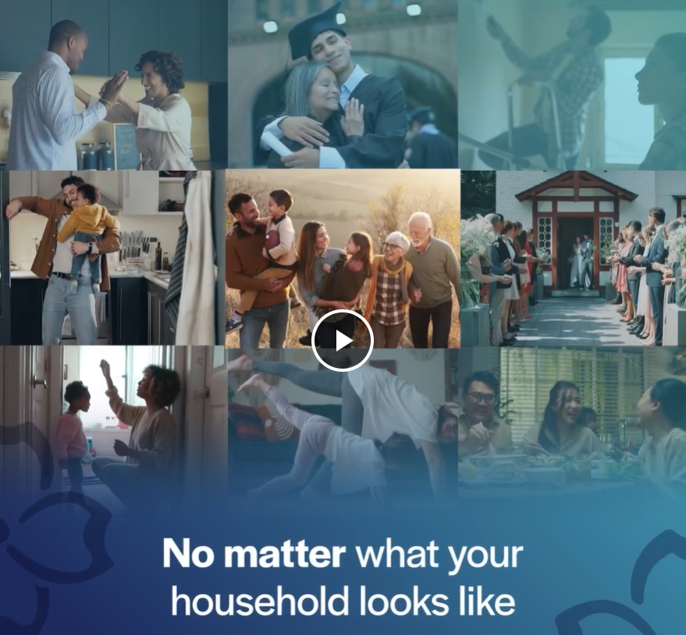  Video File Link: OEP Partner Social Post 3.mp4
Partner Post 4 | Virginians, take care of your health this holiday season. ​  Enroll in a high-quality health plan on @VAInsuranceMarketplace by January 30: Marketplace.Virginia.gov | Download asset file from the Open Enrollment Partner Content folder to include in your post.    Video File Link: OEP Partner Social Post 4.mp4
Partner Post 5 | Finish strong this year by enrolling in a health plan that goes the extra mile!​  ​  @VAInsuranceMarketplace is here to help you find the best health plan to fit your needs: Marketplace.virginia.gov/marketplace-help-center | Download asset file from the Open Enrollment Partner Content folder to include in your post.    Image File Link: OEP Partner Social Post 5.jpg

